Final Project Design Phase
Computer Science - Week 11
Oct 3, 2026 - Version 0.0.4

For complete instructions and project ideas, refer to the assignment in Canvas. Specifically, review the final project requirements before you continue below. If you have not reviewed the project requirements in Canvas (you might have to go to the modules view and check the current or past week's content), you will not be able to properly complete the parts below. In addition, it may be helpful to review the information on this Drafter documentation page.

0) Project Planning and Preparation
Successful programmers spend time planning before they begin coding. After reviewing the project requirements, answer the following questions to help guide your design and development process.
- What concepts from class or previous assignments might help you complete this project? Which programming concepts (loops, conditionals, lists, classes, etc.) do you expect to use? What programming skills do you want to improve while completing this project?
Functions and drafters will be very important in this project. I'm sure I will use loops, conditionals, functions, classes, etc. I hope to improve my understanding of drafter as it tends to be a bit tricky for me to understand.

- Which parts of the project do you expect to be the easiest for you? The hardest? Why?
I think the easiest will be making the classes, defining functions, and getting input as I'm used to doing that for other assignments and projects. The hardest will probably be the drafter as I am not the best at it in general. My understanding of routing is still pretty weak.

- Even though you have not yet designed the final project, estimate which tasks will likely require the most time and effort? Which features or components should be implemented first?
First I need to create my classes. I'm sure the splitting up of chemical equations will be pretty hard to do. I will need to import a library of basic chemistry information (like Chem Py) to get started on that. I'm going to create my pages in the beginning as well and start on implementing drafter.

- What distractions might interfere with your work and how will you minimize them? What resources will you need available while working? What questions, if any, do you still have about the assignment requirements?
Other work might distract me. I will minimize this by setting designated chunks of time to do this project. I will need ChemPy and will use the blockpy textbook.

1) Site Diagram
Create a mock-up of your planned website. We suggest you make the mockup on paper, although you can also use software like PowerPoint or Slides to make a mockup. There is other design software that could also be used, but we strongly encourage you to keep it simple. Do not spend more than 15-30 minutes detailing the mock-up. Your goal should be to make a very quick and dirty diagram, to show that you have some kind of idea.

We recommend drawing each page as a rectangle, and laying out the text, buttons, and other components inside. Then, use arrows to indicate links between pages. Label each page the way you will name each function, and then put labels on the arrows to indicate what the button links. Also write down any parameters that should come into the pages.

In addition to the pages and routes, write down what fields your `State` will have, both their names and types. Think clearly about what data will need to be persistent across the entire website.

Add photo(s) or screenshot(s) of your website mock-up and labeled diagram on the next page.

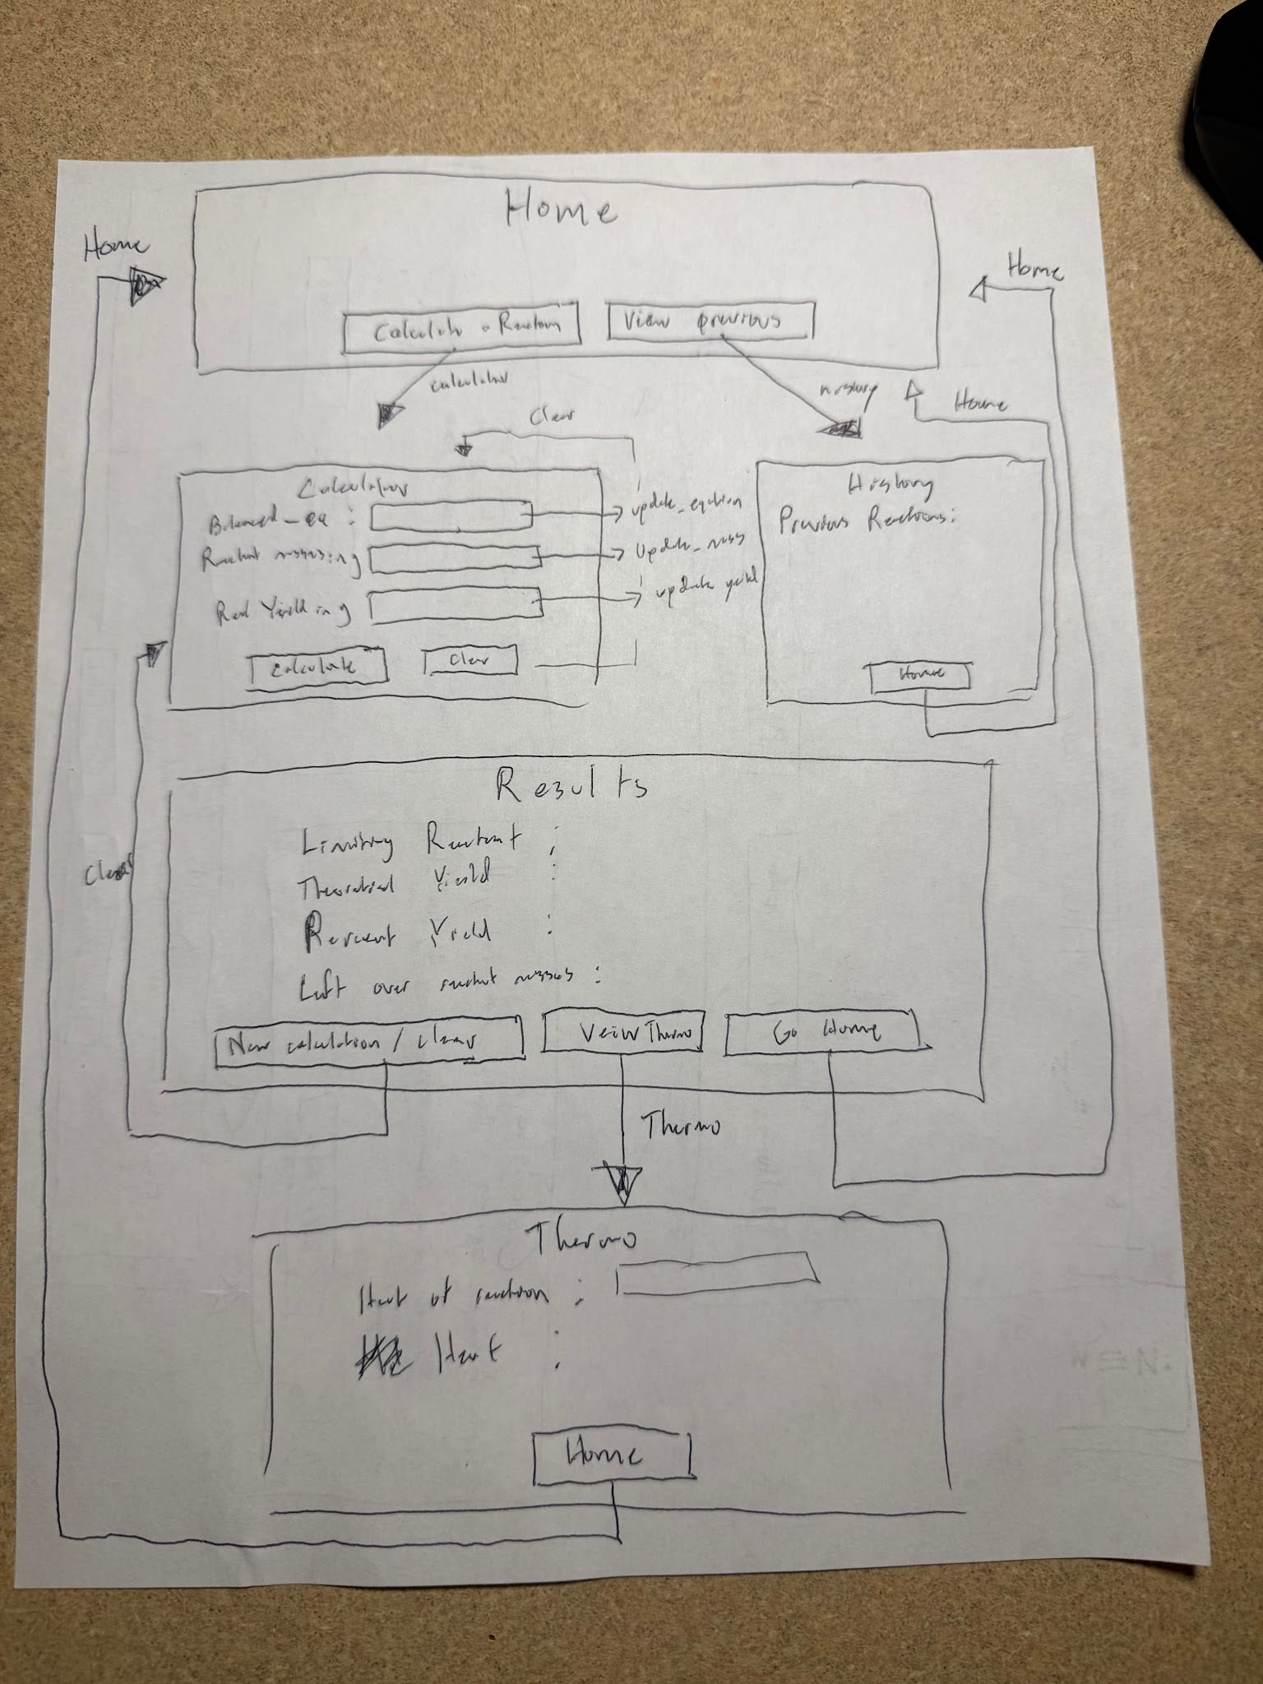
2) Implementing Requirements
This table should serve as a draft for how you will implement the requirements into your final project. You may change your ideas later on, but your final site must fulfill all the requirements.

Requirement | Implementation
Purpose/Functionality  A 1-2 sentence description of the purpose or functionality of your site | My site will take in a balance chemical equation, real_yield and reactant masses. Next, it will calculate and return percent yield, theoretical yield and heat of reaction.
State Dataclass Attributes  Minimum of 4 attributes, one of which must be a list/dict of instances of your second dataclass.  Briefly describe each attribute, its type, and how it will be meaningfully modified throughout the site. | Balanced_equation: str - A string representing the balance equation that the user wants help with.Updated upon user input  Reactant_mass: float - The mass of the reactants. Updated upon user input  real_yield : float - a number representing the actual product yielded. Updated upon user input  Result_text: str - The text that will be displayed after each calculation. Updated during calculations in order to display results  reactions: list[Reaction] - List of previously entered reactions. Updated when the user inputs a new reaction for calculation
Second Dataclass  Your second dataclass, including its attributes, their types, and how they will be meaningfully modified (if they are modified) | Class -> Reaction:  Balanced_equation: str - The balanced chemical equation that calculations will be performed on. Updated upon user input.  Limiting_reactant: str - The name of the limiting reactant. Updated when found during calculation.  Theory_yield: float - The theoretical yield in grams. It is updated when found during calculations
Routes (minimum 7)  The names of your route functions | Home  Calculator  Update_equation  Update_mass  Update_yield  Calculate  History  clear
Pages (minimum 5)  A brief description of the pages in your site | Home: The home page used to navigate.  Calculator: The page for the user to input their chemical equation, reactant masses, and real yield  Results: The page used to display the results of a calculation  History: The page containing previous reactions that the user has calculated  Thermo: The page for users to view heat of reaction calculations for an input chemical reaction
User Input (minimum 3)  Description of user input components (TextBox, TextArea, CheckBox, or SelectBox) and their purposes  For more information on these input types, see Drafter Documentation. | Balanced Equation: TextBox: Lets the user input what balanced chemical equation they would like to perform calculations on  Reactant masses: TextBox - The input for starting reactant masses.  Real Yield: TextBox - The input for the users observed yield from the reaction.
If Statements (minimum 3)  Brief description of what will be evaluated in your if statements and how they will meaningfully change the logic of the site | Limiting Reactants: Compares calculated product yield in order to find a limiting reactant. This will change what reactant will be used to calculate the theoretical yield of the reaction  Theoretical Yield: Checks that the theoretical yield is above zero. If it is below zero it will display an error message, otherwise it will display the theoretical yield  Input Check: Checks whether the user entered valid inputs (positive numbers). If not, it will display an error message
Loop (minimum 1)  This loop must iterate over the list/dict of dataclass instances in your State attribute.  Description of this loop and why it is meaningful to the site | Previous Results: This loop will iterate through a list of previous reactions and print them and their results on the history page.

LLM Conversation
If you used an LLM in any part of this work, copy and paste every part of that conversation below. Otherwise, you may be given a zero for the assignment. Obviously, these words will not all be yours, and this is the exception to the requirement at the top of this assignment that all responses be in your own words. If you did not use an LLM to assist you in this assignment, simply say so below.
Replace this text with your answer.

Final Submission
When you are finished, download this file as a Word Document (docx) and upload the file to the appropriate assignment on Canvas.

